1. Normal Dates

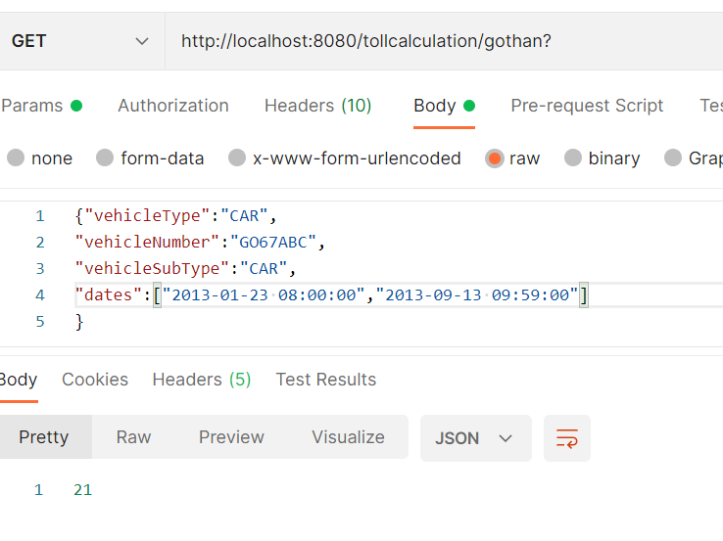

1. First Date is Saturday.

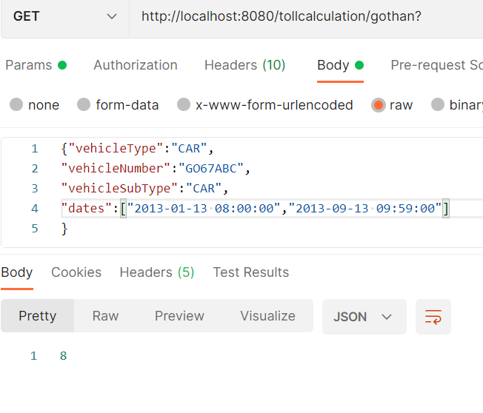

1. First Date is Saturday second is Sunday

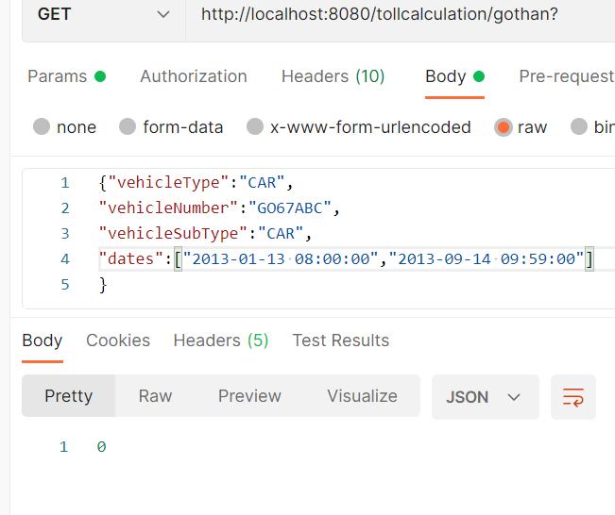

1. With July as an exception month

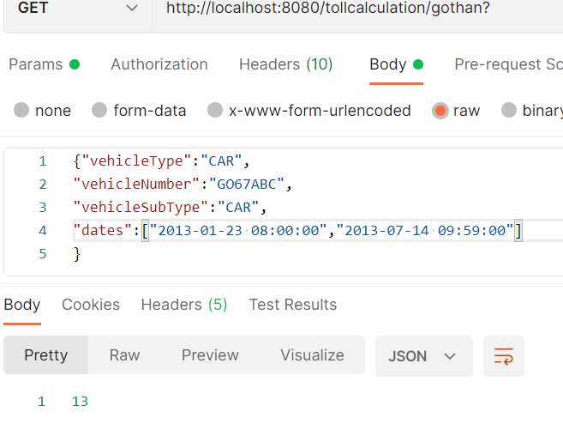

1. Exempted vehicle case (message could be modified to be more meaningful)

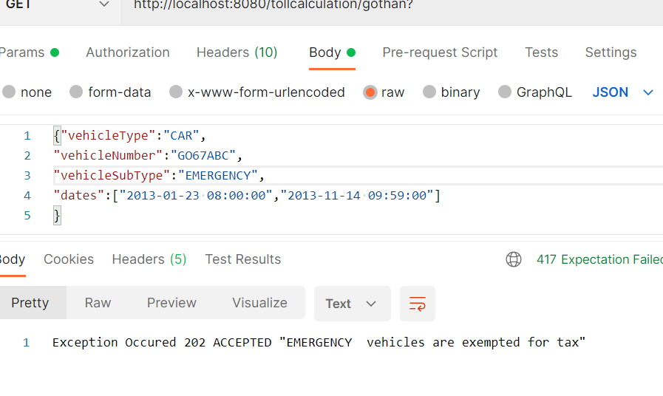

1. No tax within 60 minutes

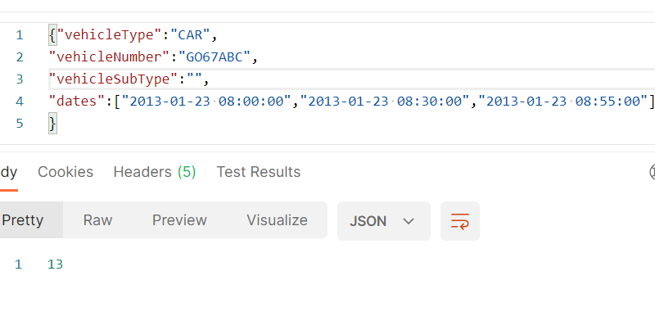

1. Publicholiday, day before publichoilday and max amount 60 is also covered.